
Development Request
Aria Systems

AMENDMENT TO PO COST SHEET ‘ISSUE/RETURN’ TO ALLOW RETURN OF TRIMS TO A DIFFERENT WAREHOUSE

New Program Template Description

New Program Template

New Program Header
Product: | Aria 2.7
Module: | PO – Style Purchase Order
Customer name: | Dare to Bare Ltd
Installed Modules: | AR, IC, SO, PO, SA, RM, SM, MA, SR, AP
Parameters setting: | Multi-Currency = Y  Multi-warehouse = Y  Material Costing method = Lot  Style Costing method = Average  Extended sizes = No  Style number format = 12 characters style code  6 characters colour

Details Section
Screen Name:
Screen Objective: The user requires the option to return trims to a warehouse other than the original issuing warehouse

This modification applies to RETURN of trims on a PO (fabric is dealt with by the Issue/Return Rolls CP). Trims are any items on the PO Cost Sheet where CTKTBOM.TYP = “3”.

The user selects Issue/Return on the PO Cost Sheet screen. The user clicks on Return and selects the Issued Lot to be returned.

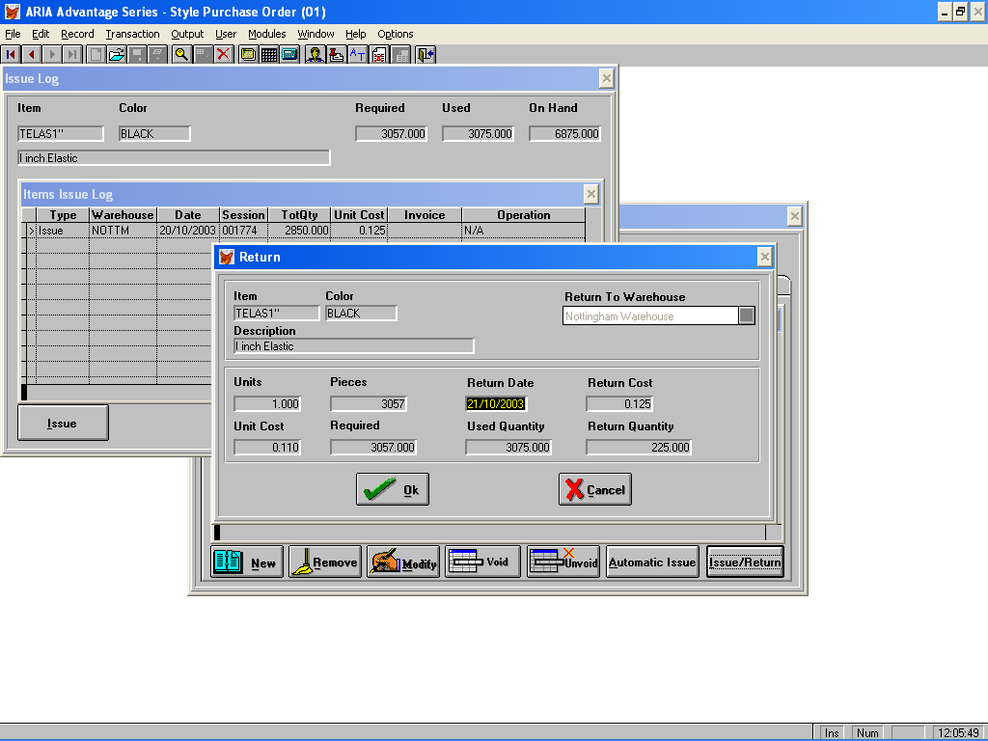

The return to warehouse will default to the warehouse from which the trim was issued but the user will be able to click and select an alternative warehouse from the drop down list. When the user selects the alternative warehouse and clicks OK, the returned quantity will then be updated to that warehouse.

If the PO Cost sheet is deleted, and there are already trims which have been returned to a different warehouse, the system should not return these trims again to the issuing warehouse. Only the Used quantity should be returned if the PO Cost sheet is deleted.

